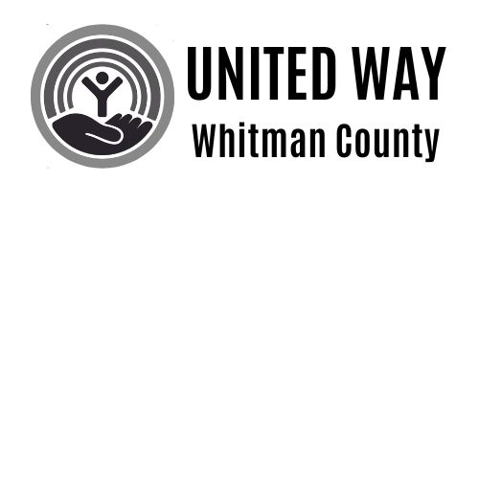

Volunteer Day of Action – June 13, 2025
8 AM to 1 PM
Volunteer Team Registration Form

Due by Monday, June 2, 2025

Yes! We would like to participate!

Company/Organization:

Contact name:

Mailing address: City: Zip:
Phone: E-mail:

Name of your organization’s volunteer team leader:

Please indicate the size of your volunteer team:
Please list the names, email addresses, and T-shirt sizes of all volunteers below. Each volunteer must also complete a photo release/waiver. (Use an additional sheet if needed.)"
Volunteer name | e-mail address | T-shirt size | Waiver collected?
What specific skills does your team have that could indicate what type of project you would be assigned to?
☐ Painting ☐ Sorting, Stacking, and Organizing ☐ Administrative
☐ Cleaning ☐ Yard Work ☐ Other:

Please list the equipment your company/organization may have available for use during the project
(shovels, painting equipment, etc.): Please list any other skills or talents your team members have that you would like to add (plumber, carpenter, craft skills, etc.):
Volunteer name | e-mail address | T-shirt size | Waiver collected?

Please have each of your team members sign a release and return the forms to UWWC along with your registration page.

Volunteer Waiver and Release of Liability

In consideration of my participation in the United Way of Whitman County “Volunteer Day of Action” (VDA) project, I hereby waive, release, and discharge any claims, demands, or causes of action against United Way of Whitman County, its sponsors, nonprofit partners, and their respective officers, employees, agents, and representatives (collectively, "Released Parties") arising from or related to my participation in this event.
This waiver includes but is not limited to any claims for personal injury, illness, death, or property damage that may occur during or as a result of my participation in the VDA project, from negligence or otherwise.
I understand and acknowledge that participation in volunteer activities involves inherent risks, and I voluntarily assume all such risks. I further agree to indemnify and hold harmless the Released Parties from all liability, losses, or expenses, including reasonable attorney’s fees, arising from my participation in this event.
By signing below, I acknowledge that I have read and fully understand this waiver and release of liability. I voluntarily agree to its terms.

Signed this day of ________________, 20_____.

________________________________________________________________________________________________
Signature Print Name

Photo Release
United Way of Whitman County – Photo & Media Release
I hereby grant United Way of Whitman County, its successors, assigns, and those acting under its authority or permission, the unrestricted right to use, reproduce, publish, distribute, and/or display photographs, video recordings, and/or audio recordings of me (collectively, “Media”), in whole or in part, in any format or medium, including but not limited to print, digital, and online platforms.
I understand that:
- This authorization applies worldwide and includes the right to use the Media alone or with other content, in color or black and white, for lawful promotional, educational, or fundraising purposes.
- I waive any right to inspect or approve the final Media or its use.
- I relinquish all rights, titles, and interests in the Media and acknowledge that United Way of Whitman County and its affiliates own all rights to the Media.
- I release and hold harmless United Way of Whitman County and all affiliated entities from any claims, demands, or liability related to the use of the Media.
By signing below, I acknowledge that I have read and understand this release and voluntarily agree to its terms.

Signed this day of ________________, 20_____.
________________________________________________________________________________________________
Signature Print Name

